|  |  |
| --- | --- |
| Name Of The Student | SENTHIL KUMARAN.M |
| Internship Project Topic | TCS iON RIO-125: Digitization of Attendance Management System - Application Development |
| Name of the Organization | TCS iON |
| Name of the Industry Mentor | MAHARAJAN MS |
| Name of the Institute | PANIMALAR ENGINEERING COLLEGE, CHENNAI |
|  |  |

|  |  |  |  |  |
| --- | --- | --- | --- | --- |
| Start Date | End Date | Total Effort (hrs.) | Project Environment | Tools used |
| 25-07-24 | 25-08-24 | 125 | Chrome, Windows 11, Android 12 | MS Office, App Sheet |

**TABLE OF CONTENT**

**Acknowledgement**

I am highly indebted to TCS iON for their guidance and constant supervision as well as for providing necessary information regarding the project & also for their support in completing the project.

I would like to express my gratitude towards my parents and my academic mentor, for their kind co-operation and encouragement which help me in completion of this project.

I would like to express my special gratitude and thanks to my industry mentor for giving me such attention and time.

**Objective**

The objective of this project is to develop a mobile application for attendance management system for students.

**Introduction / Description of Internship**

In current scenario, marking attendance in the class session is an essential task of the subject handlers, since marking the attendance can regulate the students to attend the sessions and verify the number of students in the class. The management and maintenance of student information is a key task for any institution.

The task of marking attendance was traditionally carried out manually with a log book. Later, this task is carried out by the desktop applications. The desktop application is a standalone application installed in the particular desktop or laptop and the tasks can be performed only with that particular desktop system. The main drawback of this system is that the computer systems are not portable hence it cannot be kept anywhere to perform the task such as mark and attendance entry.

These limitations of the traditional systems are overcome by the mobile applications. The mobile application allows the users to install this application in their mobile devices. The user can update the student attendance and mark details in the local mobile database by connecting their mobile devices with the server which keep the attendance details through internet. Hence, the updated attendance details can be viewed even offline. In order to reduce the manual work and to achieve more efficiency in managing the student information, this project presents a mobile application to manage the student attendance more easily and effectively. The proposed application can store student information to the server database and it can be retrieved by the mobile phone anytime the users want to. Through this system, teachers can easily record the student attendance and can generate the reports.

**Internship Activities**

1. Learning how to do work in App Sheet
2. Learning manythings for digital discussion rooms
3. Our mentor also give many instruction and help for the daily Activities
4. Working on daily internship and submitted to the mentor if any correction they will tell what to do.
5. So it is very useful for complete the internship

**Approach / Methodology**

1. Firstly, we create an application through the App Sheet tool, which is a part of Google Cloud for creating applications without coding.
2. Then, we start customizing the application according to our project needs, i.e., identify and store the attendance details that the school would like to capture for each student in the class. The details could be roll number, name, grade and subject.
3. The Attendance application will display the different courses, and the students of different grades enrolled to it. The professor will be able to mark them present the moment they join the class, their email will uniquely identify each student.
4. The data of marked students will be stored safely in an google spreadsheet which can thus be used to present different statistics which can be filtered using roll numbers, grades and courses.

**Assumptions**

These project will be made with App Sheet without coding we can use the app

and modify what we needed and also the project is about attendance management system so we can add the students and courses what we needed ..

An attendance management system refers to **an organization's approach to tracking students time and attendance information**

**Exceptions / Exclusions**

1. We can add a new course in it
2. We can add the number of students in it
3. We can add the course and the student details in it
4. We can access the student attendance also..
5. Each students details we can in the mobile applications
6. And access the attendance according to the course with date and time

**Charts, Table, Diagrams**

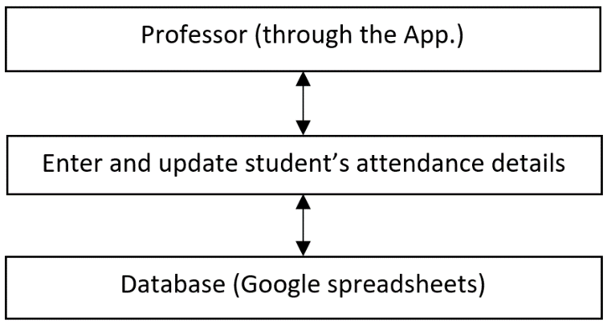

**Algorithms:**

The algorithm of the project states that by using App Sheet and google cloud sheet will be used in this

Project . the concepts of students attendance will be handled by staff in mobile Applications

**Course table consist:**

We can add the course name and the descriptions of the course

As well as we need to uploaded image for the course finally the course table will be

Created successfully.

**Adding students and details:**

In the student attendance details are consist of the student name

Course of the student ,Gmail of the student ,Profile of the student ,

Attendance of the student,Finally the each and every detail will be stored according to the course

Both attendance of students details will be stored in the database (google sheet**)**

**Data base (google sheet)**

In the database the process of each and every detail will be stored in the google sheet

The attendance log, student and the course

In the attendance log there will be stored the attendance of the students with date and the Time In an student table it will be stored the student name,Course of the student ,Gmail of the student ,Profile of the student and if any new student detail will be added means it will display in the google sheet . In the course table it will be consist of Course name ,Course descriptions ,Course image and if any new course detail will be added means it will display in the google sheet … these are the connectivity of the database

**Challenges & Opportunities**

**Challenges:**

1. Finding more information and details for browser
2. It’s a new lifestyle
3. The internship have an pre test ,project test and also the daily reports

**Opportunities** :

1. I will learn many information from this internship
2. My mentor will update every information in report it is very usefull

For correcting my mistakes

1. After doing this Intership I have a goal and task to complete every day
2. I learned myself without any help and following my mentor instructions

**Risk:**

1. I have find many challenging while submitting daily report and test
2. It is very new to learn

**Recommendations**

In this internship each and every process will explain in the digital discussion room and by our mentor while submitting daily reports . continue the process and give more informations in the digital discussion room it will heip for the Project to develop more…

**Outcome / Conclusion**

Student’s details that school would like to record as attendance.

Mobile application for attendance management.

**Enhancement Scope**

There are enormous ways to enhance the scope of this project,

1. Firstly, in the present scenario the professor/teacher has to manually click on the “Attending” button to record the attendance of the particular student. The enhancement that we can expect here is that as soon as the student joins the online class, the application automatically records the attendance of the student.
2. Secondly, along with the attendance of the students we can also record their performances in weekly quizzes, assessments and viva sessions, which will then become easy for their professors to grade them accordingly in their final semester examinations.

**Link to code and executable file**

1. Browser Link
2. Run the app directly in your browser
3. **https://www.App Sheet.com/Template/AppDef?appName=Untitledspreadsheet-947241808&utm_source=share_app_link**

**Research questions and responses**

Many information will be give in the digital discussion rooms

In this internship I have learned and research many information for browser and YouTube

The link are given below:

<https://www.google.com/aclk?sa=l&ai=DChcSEwjE1IHT39T4AhUQkmYCHeIoBVIYABABGgJzbQ&ae=2&sig=AOD64_3-Zyl41EFOVAw91D79j5sGg7uE4w&q&adurl&ved=2ahUKEwjA9vjS39T4AhVETWwGHSuCATQQ0Qx6BAgGEAE>

<https://www.google.com/aclk?sa=l&ai=DChcSEwjE1IHT39T4AhUQkmYCHeIoBVIYABAAGgJzbQ&ae=2&sig=AOD64_3bA0bI_N2oAojFDdzQXPWkpg6vIA&q&adurl&ved=2ahUKEwjA9vjS39T4AhVETWwGHSuCATQQ0Qx6BAgEEAE>